**TUẦN 8 – AV 8**

**THEME 5: STUDY HABITS**

**READ + WRITE**

**NỘI DUNG BÀI HỌC**

**READ**

1. Language /ˈlæŋgwɪdʒ/ (n); ngôn ngữ

2. Different /ˈdɪfrənt/ (adj): khác nhau

3. Way /weɪ/ (n): cách

4. List /lɪst/ (n): danh mục, danh sách

5. Meaning /ˈmiːnɪŋ/ (n): nghĩa, ý nghĩa

6. Mother tongue /ˈmʌðə(r ) tʌŋ/ (n): tiếng mẹ đẻ

7. Learn by heart /lɜːn baɪ hɑːt/ : học thuộc lòng

8. However /haʊˈevə(r)/ (adv): tuy nhiên

9. Other /ˈʌðə(r)/ (pron.): người khác

10. Instead /ɪnˈsted/ (adv): thay vì như thế

11. Example / ɪgˈzɑːmpl/ (n): thí dụ

12. Sentence /ˈsentəns/ (n): câu(văn)

13. In order to + V(infinitive): để mà

14. Even /ˈiːvn/ (adv): thậm chí

15. Use /ju:s/ (v): sử dụng

16. Piece /piːs/ (n): mảnh, miếng (giấy,…)

17. Stick /stɪk/ (v): dán

18. Somewhere /ˈsʌmweə(r)/ (n): nơi nào đó

19. So as to + V(infinitive): để mà

20. At any time: bất kỳ lúc nào

21. Come across /kʌm əˈkrɒs/ (v): tình cờ gặp

22. Underline /ˌʌndəˈlaɪn/ (v): gạch chân(dòng chữ)

23. Highlight /ˈhaɪlaɪt/ (v): làm nổi bật

24. Important(adj): quan trọng

25. The same /seɪm/ (adj): giống

26. Revision /rɪˈvɪʒn/ (n): sự ôn tập

27. Necessary /ˈnesəsərɪ/ (adj): cần thiết

28. Revise /rɪˈvaɪz/ (v): ôn tập

29. Practice /ˈpræktɪs/ (v): rèn luyện

DERIVATIVES: UNIT 5 STUDY HABITS

1. Pronounce (v):phát âm - Pronunciation (n): cách phát âm

2. Pride (n): sự hãnh diện - proud (adj.): tự hào, hãnh diện - Proudly (adv )

3. Revise (v): ôn tập - Revision (n): sự ôn tập

4. Need (v): cần - Necessary (adj.): cần thiết ≠ Unnecessary (adj.) - Necessarily (adv)

5. Learn (v): học - Learner (n): người học

6. Explain (v): giải thích - Explanation (n)

7. Important (adj.): quan trọng ≠ Unimportant (adj.) - Importance (n)

8. Bad (adj.) - Badly (adv)

9. Good (adj.) - Well (adv)

10. Soft (adj.) - Softly (adv)

Task 1. True or false? Check (✓) the boxes.

|  |  |  |
| --- | --- | --- |
|  | **T** | **F** |
| a. All language learners write the meaning of new words in their mother tongue.  ⟹ Some learners write the meaning of new words in their mother tongue. |  | **✓** |
| b. Some learners write examples of words they want to learn. | **✓** |  |
| c. Every learner tries to learn all new words they come across.  ⟹ Many learners do not try to learn all new words they come across. |  | **✓** |
| d. Many learners only learn new words that are important. | **✓** |  |

**Task 2. Answer the question.**

a) Do learners learn words in the same way?

b) Why do some learners write example sentences with new words?

c) What do some learners do in order to remember words better?

d) Why don’t some learners learn all the new words they come across?

e) What is necessary in learning words?

f) How should you learn words?

**KEYS**

a. No, they don't. They learn words in different ways.

b. To remember how to use the word in the right way.

c. They write each word and its use on a small piece of paper and stick it somewhere in their house so as to learn it at any time.

d. Because they only want to learn important words.

e. Revision is necessary in learning words.

f. Learners should try different ways of learning words to find out what is the best.

WRITE

1. Body /ˈbɒdɪ/ (n): thân thể

2. Heading /ˈhedɪŋ/ (n): đầu đề

3. Pleased /pliːzd/ (adj): vui long

4. Hear /hɪə(r)/ - heard(v): nghe

5. Enjoyable /ɪnˈdʒɔɪəbl/ (adj): thú vị

6. Vacation /vəˈkeɪʃn (n): kỳ nghỉ

7. Science /ˈsaɪəns/ (n): môn khoa học

8. Result /rɪˈzʌlt/ (n): kết quả

9. Poor /pɔː(r); (US) pʊər/ (adj): nghèo, xấu, tệ

10. Lunar /ˈluːnə(r)/ (adj): thuộc âm lịch

11. Celebrate /ˈselɪbreɪt/ (v): tổ chức(lễ)

12. Postcard (n): bưu thiếp

13. News /njuːz; / (n): tin tức

14. Mother’s day(n): lễ người mẹ

15. Bay /beɪ/ (n): vịnh

**Task 1. Look at Hoa's letter to Tim. She wrote it at the end of term. Identify the sections. Label them with correct letter.**

A. Body of the letter

B. Heading - writer’s address and the date

C. Closing - Your friend/ Regards/ Love

D. Opening - Dear ...,

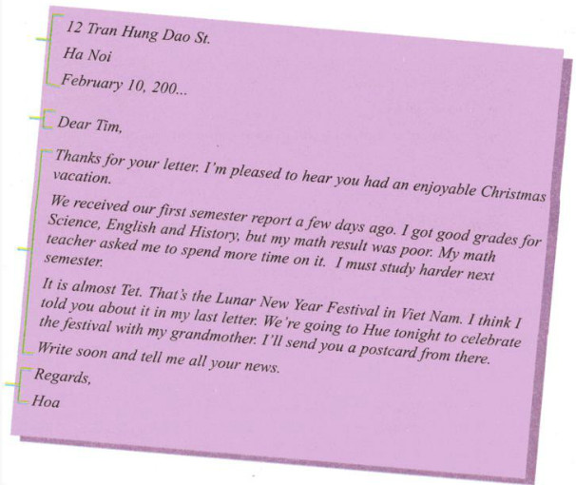

**Task 2. Now help Lan write a letter to her pen pal Donna in San Francisco. Use the information in the box.**

|  |
| --- |
| Mother’s Day  second semester report / last month  good grades / Geography / Physics / Math  teacher / tell / improve English / History  in a few weeks / Mid-Autumn Festival / moon festival  Ha Long Bay / aunt and uncle / bus / this afternoon  send you / postcard |

**SUGGESTED ANSWER**

124 Hai Ba Trung St.

Ha Noi

June 5, 200...

Dear Donna,

Thanks for your letter. I'm happy to hear that you had a nice Mother’s Day.

I received my second-semester report last month. I got good grades for Geography, Physics, and Math, but my History and English results were not very good. My former teacher told me that I should improve English and History. I am spending more time on them this summer. And I hope I'll be better at the two subjects next year.

The Mid-Autumn Festival will come in a few weeks. That’s the Moon Festival in Viet Nam. I'm going to Ha Long Bay with my aunt and uncle by bus this afternoon. I'll send you a postcard from there.

Write to me as soon as possible. I'm looking forward to hearing from you.

Fondest wishes,

Lan